Technologies Used:

* JavaScript
* HTML
* CSS
* React

Running the Application:

* Have Nodejs already installed (My version 5.6.0).
* CD to the exercise folder (here “Solution”).
* Run “npm install”. This will install all dependencies.
* Run “npm start”.
* In your browser, go to “localhost:<the port set in “webpack.config.js”>”   
  (The port is currently set to 8002)

Dealing With Responsiveness:

* Media queries
* Flex
* Meta viewport
* Min-width
* Percentage units

Dealing with Cross-Browser Support:

* Using CSS properties recognized by all modern browsers.
* Using additional CSS properties for particular browsers.

Pages Created:

* All mandatory pages: Homepage, Homepage Logged-In, Login Forms, & Sign Up Forms
* Selective page: Profile Page

Note:

Most of the work was done prior to having access to “Inspect” in Invision (on Monday), hence why some photos, fonts, dimensions are not exact as those in the prototype.

**Homepage:**

Responsiveness example:

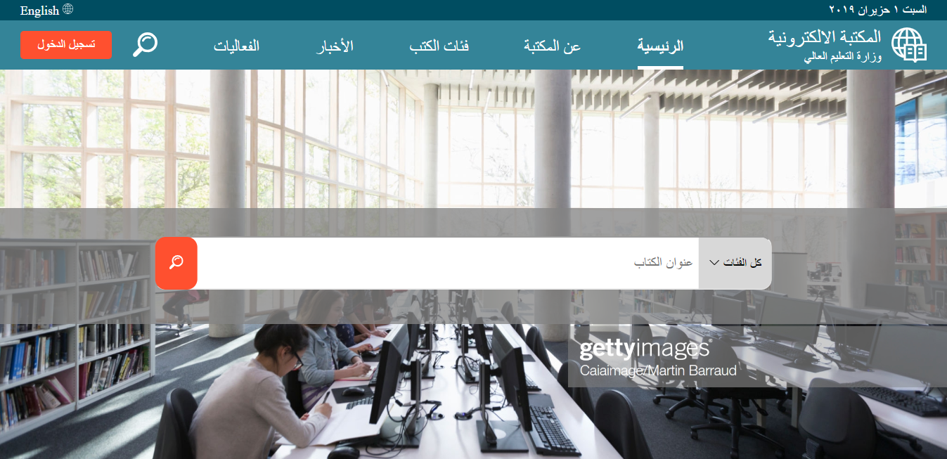

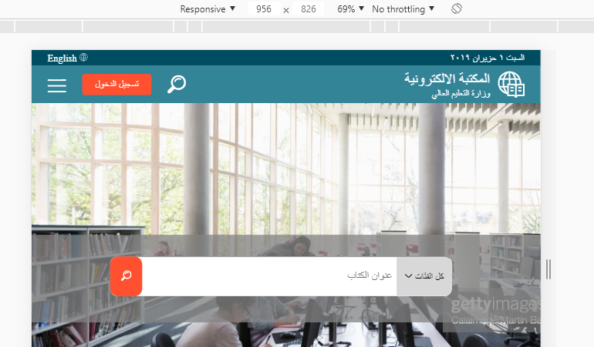

* In the menu above, book categories and news are clickable which will expand their subcategories.
* In the smaller view, the three-line menu icon is clickable, and will expand into the menu options.

**Login Page:**

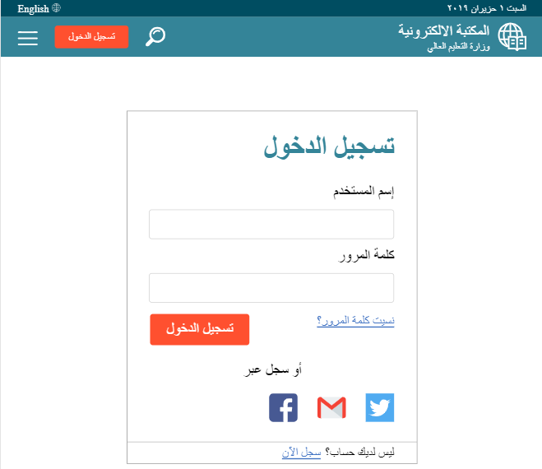

* The globe and “Ra2isiyya” button in the menu will return you to the homepage without sign in.
* All other interactions on Invision are implemented.

**Homepage Logged-In:**

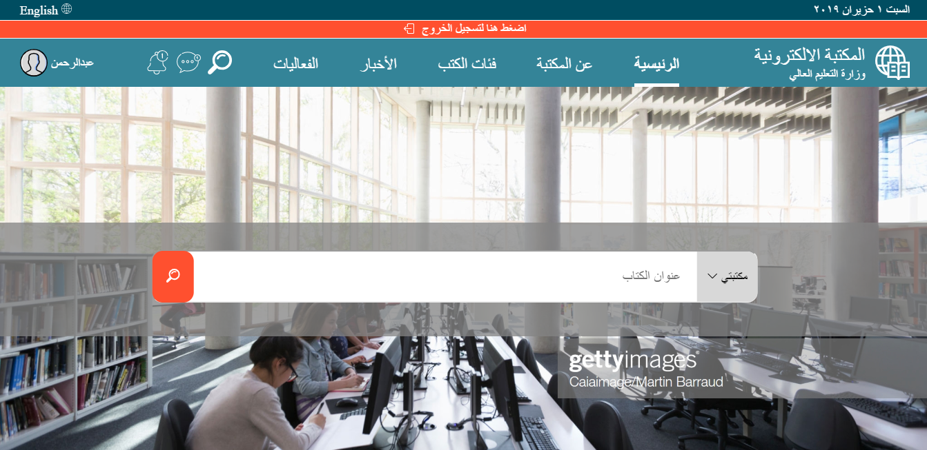

* Login is detected by adding an object to local storage when a user signs in or signs up.
* The object is destroyed when the user clicks on the log out bar.
* Changes from the logged out version:
  + Main Menu bar
  + “Maktabati” in the search bar.
  + “I5tarna Lakum” in “Tasafa7 al Kutub”
  + Changes in the advertisements section titles.

**Profile Page:**

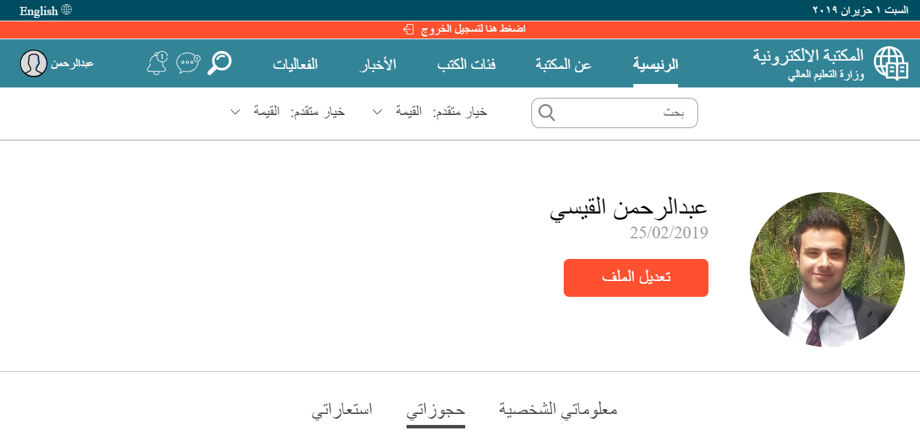

* The “Search” icon is clickable and will expand to a search box with multiple advanced options.
* The book reservation entries in the below part of the page are responsive too.

**Signup Forms:**

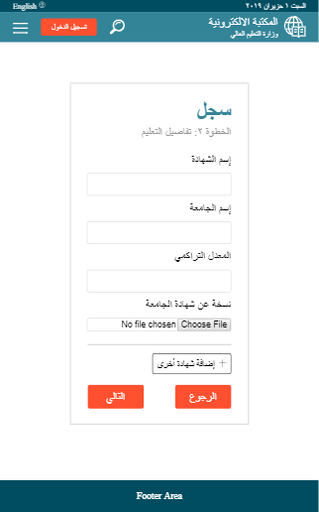

* There are three steps in the signup form (navigate with “Al Ruju3” and “Al Tali”).
* In the second step of the form, the user can add multiple degrees by clicking on “idafat shahada o5ra”.
* When the user submits the form, he will be redirected to the logged-in homepage.
* Possible improvement on the sign-up form: add validations to the steps.